## **Sales Data Analysis of Electrohub**

###Electrohub sells a range of consumer products including Electronics, Footwear, Clothing, Accessories, Kitchenware, Bags, and Personal Care. To visualize the top/bottom 5 products by sales, profit, and quantity sold, while tracking sales trends over time (daily, monthly, quarterly, annually). Display the relationship between sales and profit, compare metrics between selected periods, show average discounts per category, total orders, and relevant fields for each order. Include sales data by city.

###Questions:

-1) Top/Bottom 5 product by Sales/Profit/Quantity Sold.  
-2) How do sales trends vary over time (daily, monthly, quarterly, annually) ?  
-3) Show relationship between sales & profit.  
-4) Compare sales/profit/quantity sold between any two periods selected by the user.  
-5) Average discount offered in each discount category.  
-6) Total number of orders.  
-7) Show Sales/Profit/Discount/Net Sales/All remaining fields for each order that could be filtered using visual filters.(Product/Date/Customer ID/Promotion Categories)  
-8) Show sales by different cities.

-*1) **Top/Bottom 5 product by Sales/Profit/Quantity Sold.\***

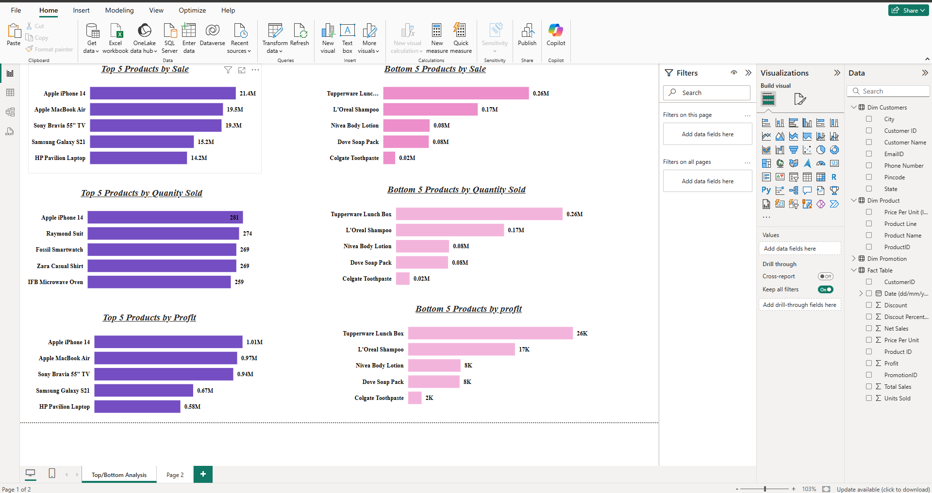

**Sales trends vary over time (daily, monthly, quarterly, annually)**

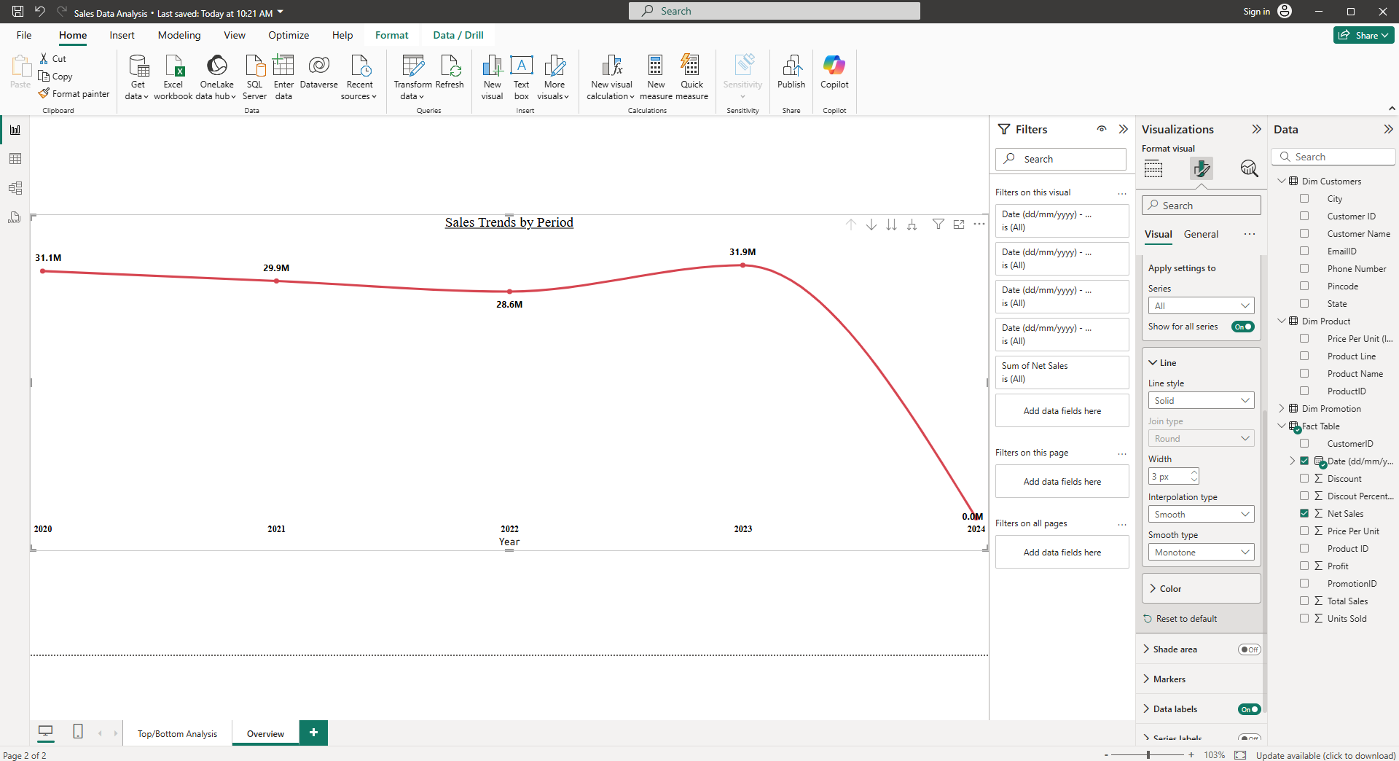

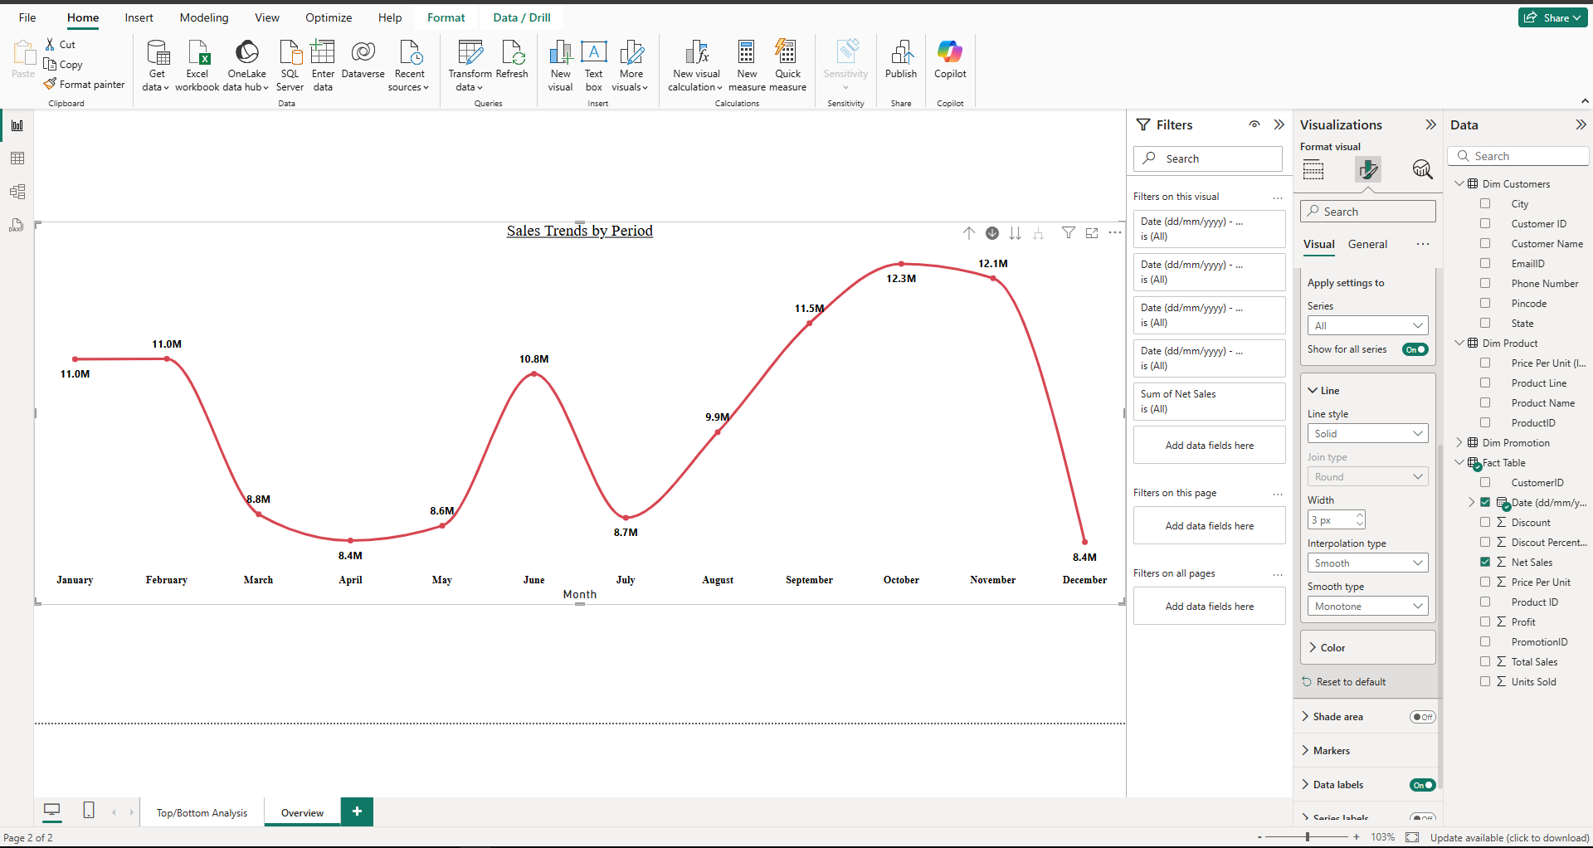

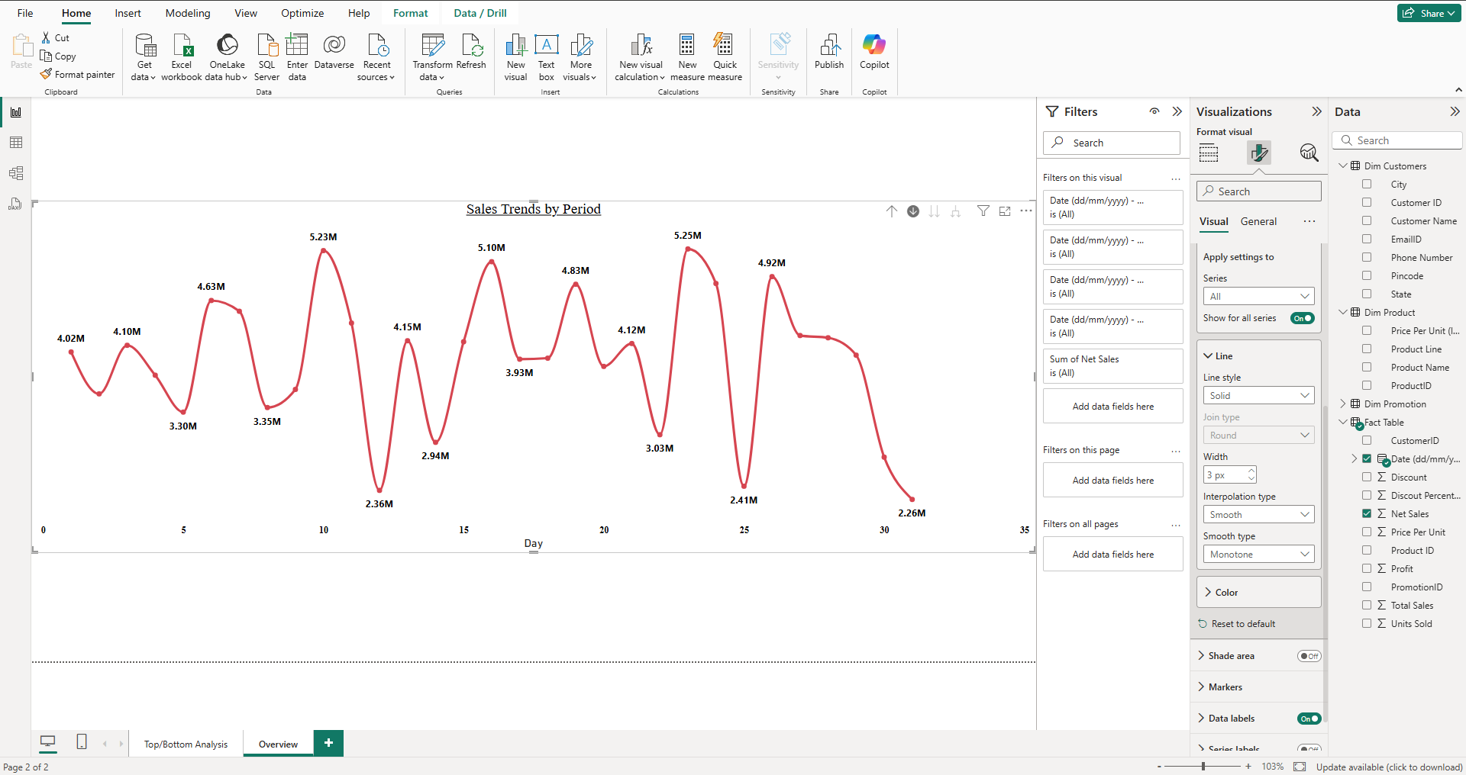

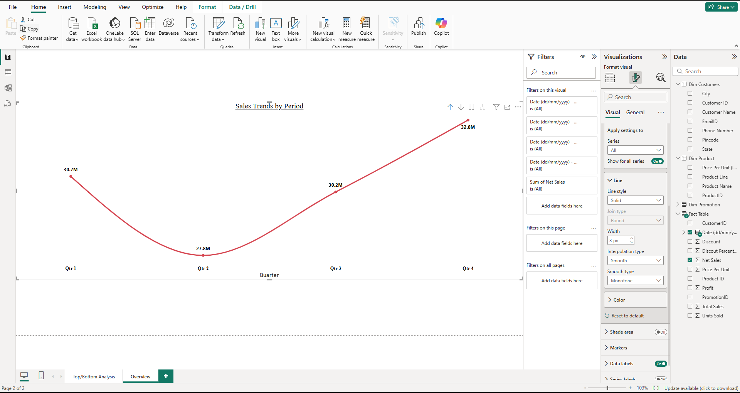

5) Average discount offered in each discount category and relationship between sales & profit.

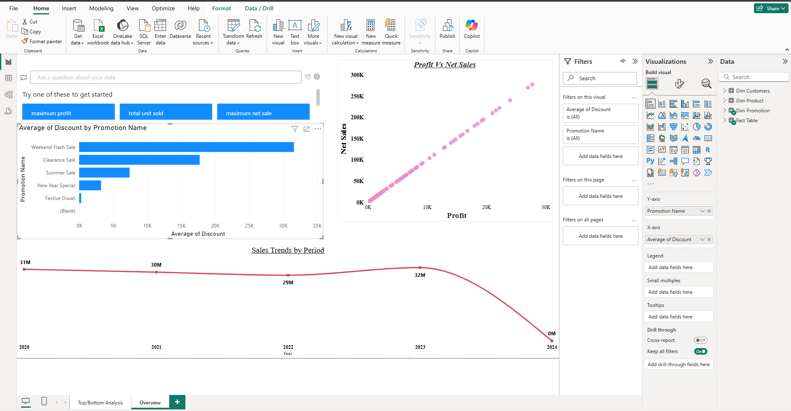

.

**Sales By diiferenct cities in india**

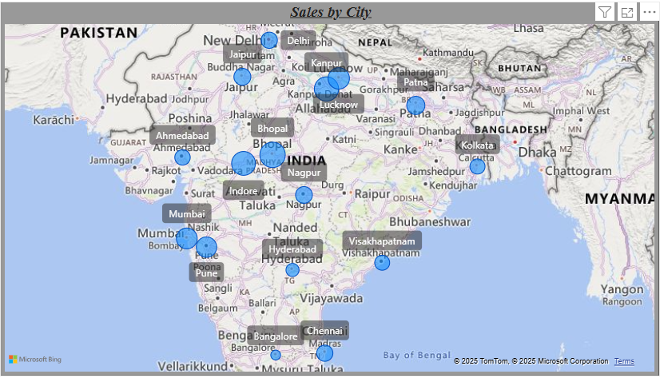

**Relationship of orders with city and provfit vs net sales**

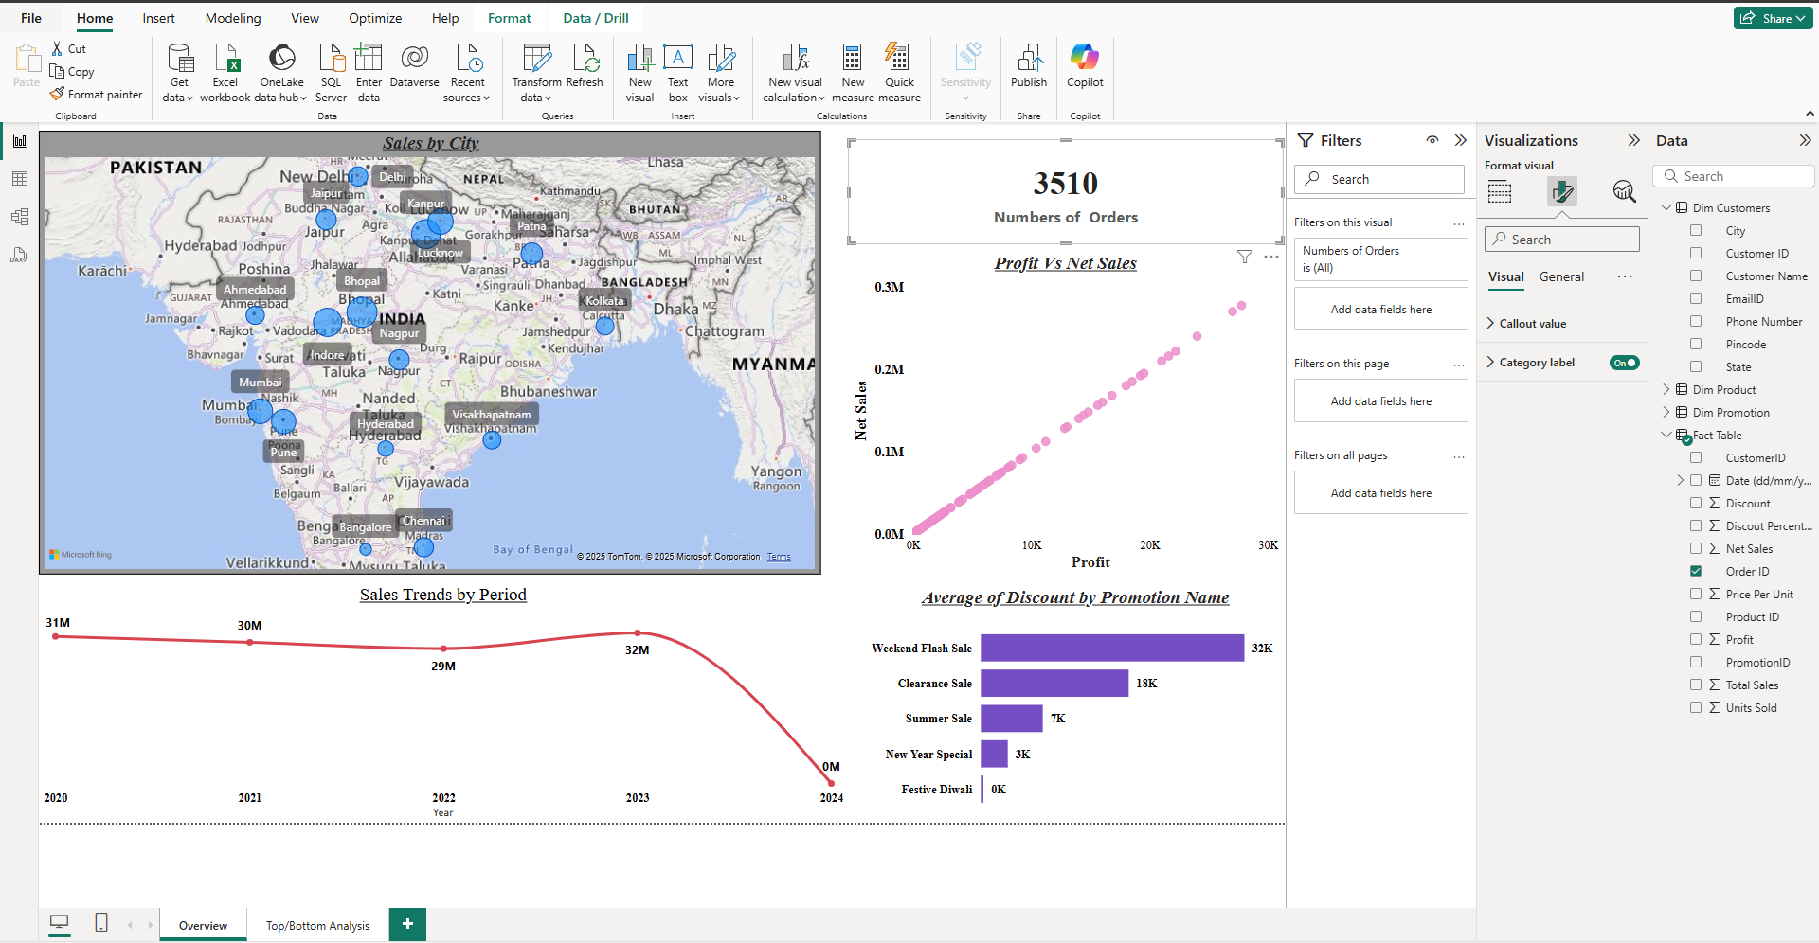

Comparison of sales/profit/quantity sold between any two periods selected by the user

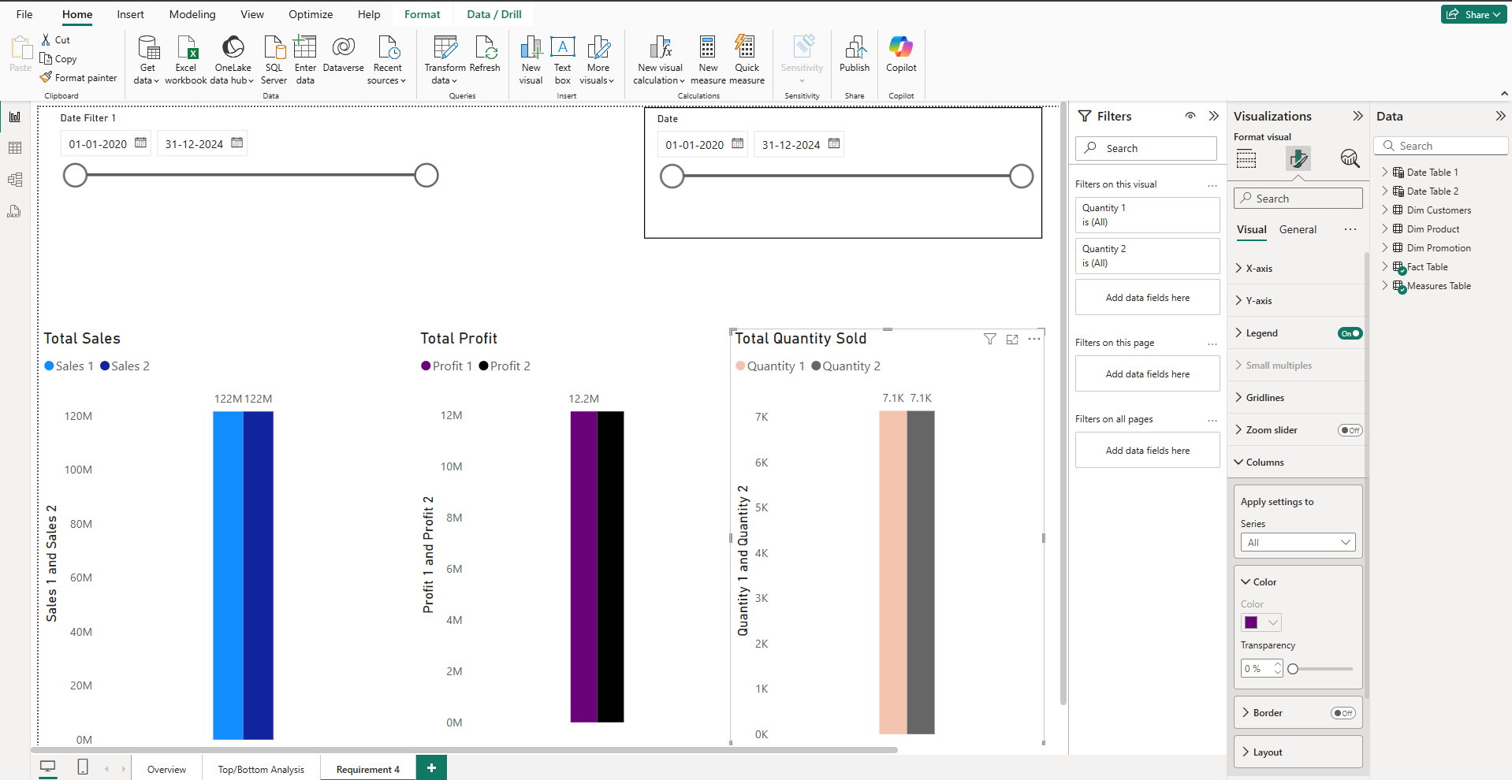

**Displaying Sales, Profit, Discount, Net Sales, and all other relevant fields for each order, which can be filtered using visual filters such as Product, Date, Customer ID, and Promotion Categories.**

